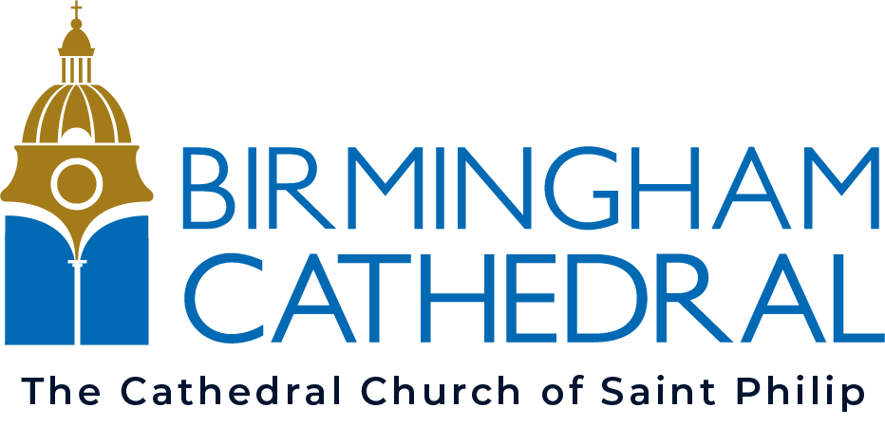
VOLUNTEER
APPLICATION FORM
Name / Address / Contact details:
Full name
Address
Name known by
Phone mobile
Phone landline
Email address
Preferred method of contact
Current occupation / study | □ Work □ Study □ Full time □ Part time □ Retired  Please give details:
Why would you like to volunteer at Birmingham Cathedral?

Experience and qualifications. Please give any relevant information that would help you in your chosen role.

Please indicate your availability. Please note: you may be asked to work evenings, weekends and bank holidays
Monday |  | Tuesday |  | Wednesday |  | Thursday |  | Friday |  | Saturday |  | Sunday
AM | PM | AM | PM | AM | PM | AM | PM | AM | PM | AM | PM | AM | PM

Where did you hear about volunteering with us?

Referees. Please provide the name and contact details of two referees.
Name/address:

Relationship to you:
Email/phone
Second referee
Name/address:

Relationship to you:
Email/phone

Data Protection Act:

In accordance with the 2018 Data Protection Act I agree that the cathedral may hold and use personal information about me for volunteering reasons and to keep in touch with me. This information including that contained in this form can be stored on either manual or computer files. It will be held securely and only accessed by authorised personnel.

Diversity and Inclusion
We are committed to diversity and inclusion in volunteering at Birmingham Cathedral. Our aim is to have a diverse team of people and a wide selection of opportunities available.
Inclusive access is a vitally important element in extending welcome to volunteers in the widest sense. This includes not only physical access for people with mobility impairments but also those with autism, dyslexia, visual or auditory impairment. Those who have varying educational and language backgrounds and those for whom cathedrals and Christianity are completely unfamiliar territory.
We have a diverse range of volunteering roles which should attract a diverse range of volunteers. We want to ensure our volunteers reflects the diversity in society. We are committed to ensure our Volunteering is inclusive, equitable and accessible to all.
We aim to be inclusive, recognizing the contribution and benefits that community cohesion can make. Having inclusive practice embedded in our cathedral means all volunteers will feel the benefits.

Declaration
By signing this form, I confirm that the information supplied is true and accurate. I understand that any offer of volunteering with the cathedral is subject to the satisfactory receipt of documentation including references and a possible DBS check.
Signature:

Name:

Date:

For Office use only:
Role:
Interview date:
Interviewer comments:
References gained:
DBS gained: (if required)
Start date:
Working pattern:
Line managed by:

